Installing Apache Tomcat on Windows
Step 1: We need to first install the Tomcat 10 zip file from this website. On the website, select the 64-bit Windows zip (PGP, sha512) in the Core section to start the download process for the Tomcat zip file.
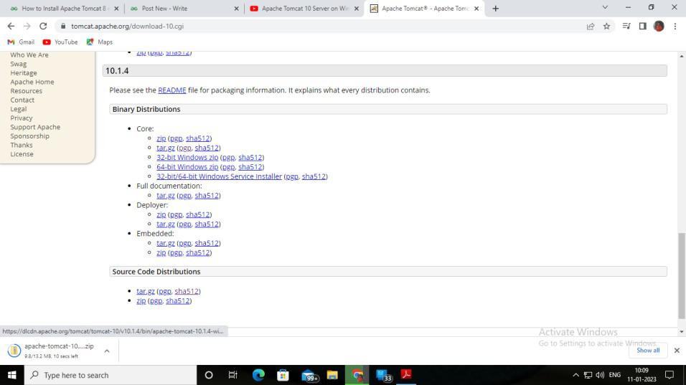
Step 3: Unzip Tomcat 10 Zip File. Go to the location where you have downloaded the Tomcat 10 zip file. Right-click on the apache tomcat file place the cursor on 7-Zip and click on Extract Here to extract the folder.
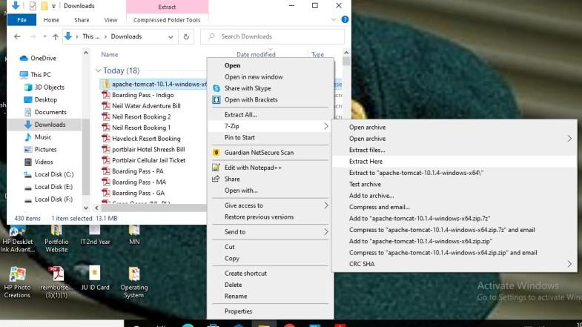

Step 4: Creating JAVA_HOME Variable. Click Start then in the search bar, search for “Edit the system environment variables” and click on it. The following System Properties box will open. Select Environment Variables in the box.
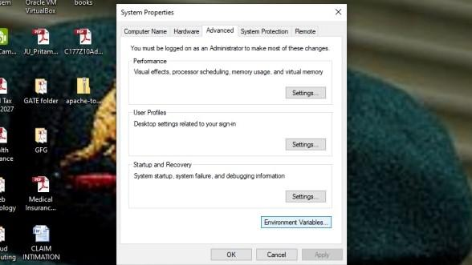

On clicking Environment Variables the following box will open.
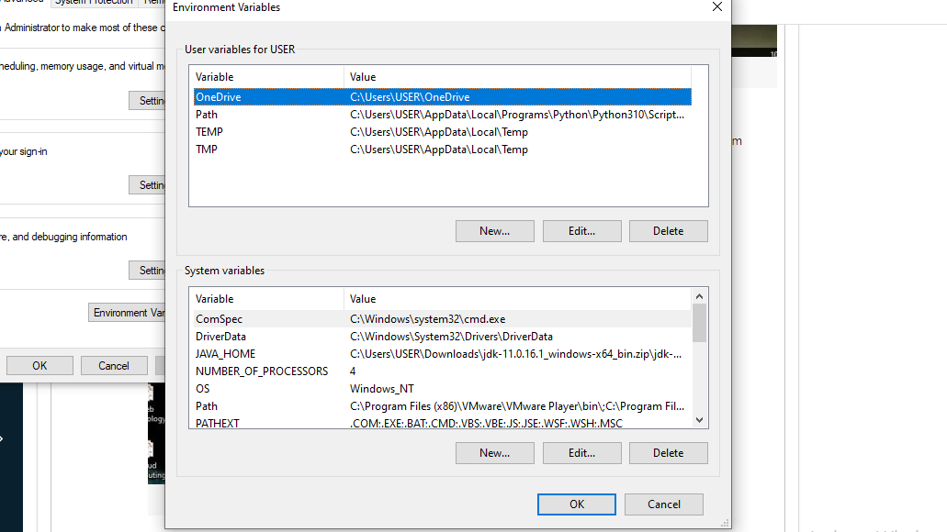
Step 5: We have to create a JAVA_HOME variable and insert the path of the JDK file stored in our computer, which will be shown below. So select New from the System variables in the above picture. A New System Variable box will be opened where we will have to fill in the Variable name and Variable value.

Step 7: Paste the JDK path from the above picture into the Variable value field and in the Variable name field, give the name JAVA_HOME as shown below.
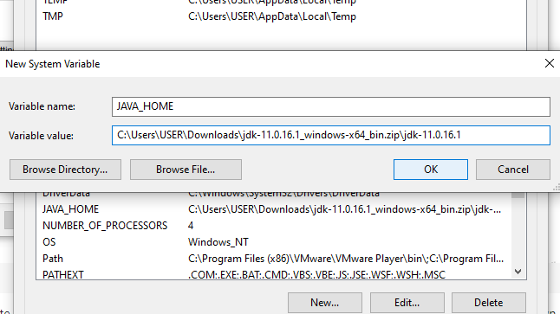

Step 8: Check the Working of Tomcat. Open the extracted apache tomcat file. We will see all the following files in them. Among them open the batch file named “startup”.
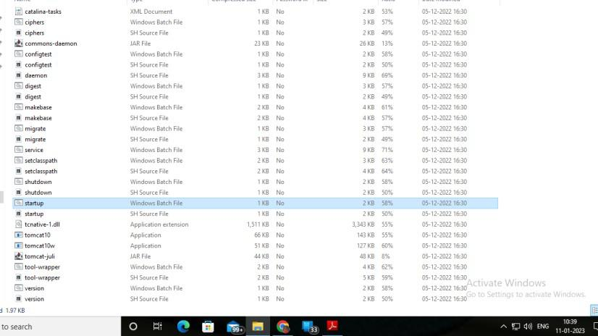

Step 9: Check if the Startup Windows Batch File is running properly.
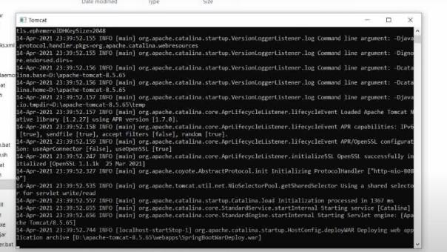

By default, the server port number is 8080.
Step 10: Successful Installation of Tomcat. Our next step is to open an internet browser like Google and type in the address
http://localhost:8080 or 8081
Then click enter and the following browser will appear suggesting the successful installation of Apache

If Suppose Appache Not INstall Properly We use this methode ……

Step 1:(WILL CREATING DYNAMIC PROJECT) CHECK WHETER THE APACHE IS INSATLL OR NOT
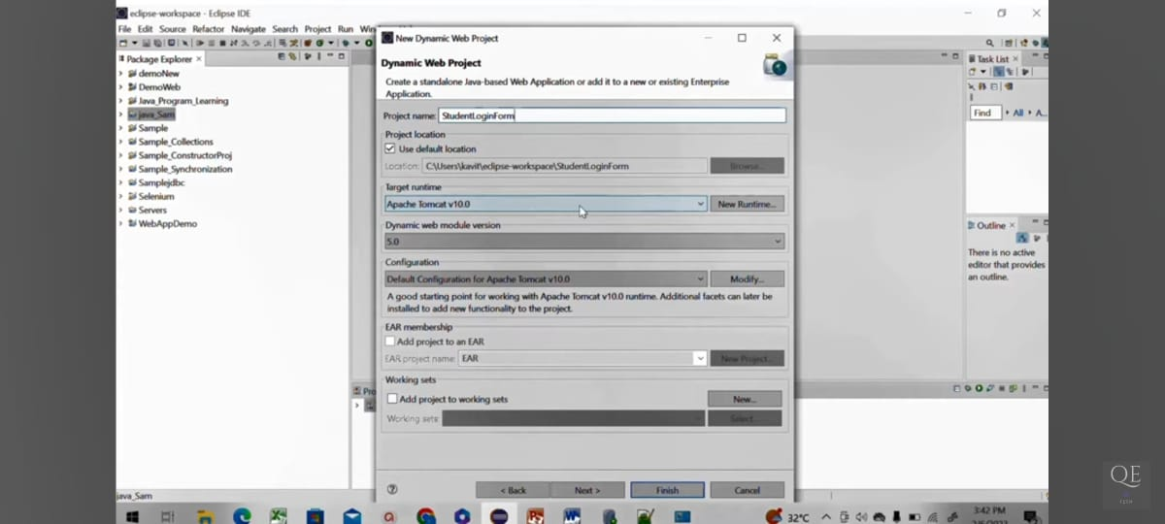
IF ITS NOT SHOWING USING THIS METHODE …

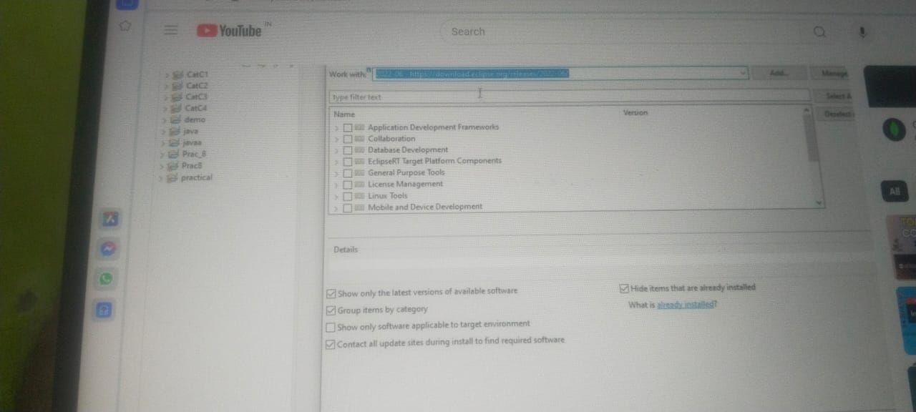
SELECT (REALESE) OPTION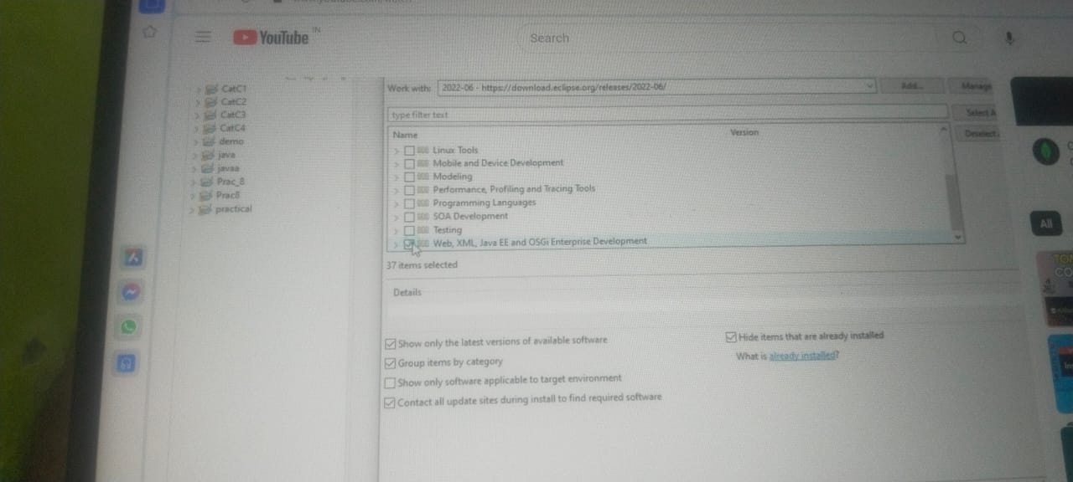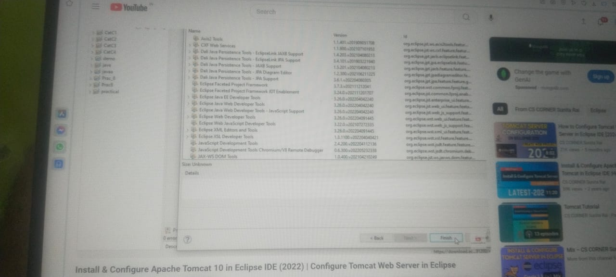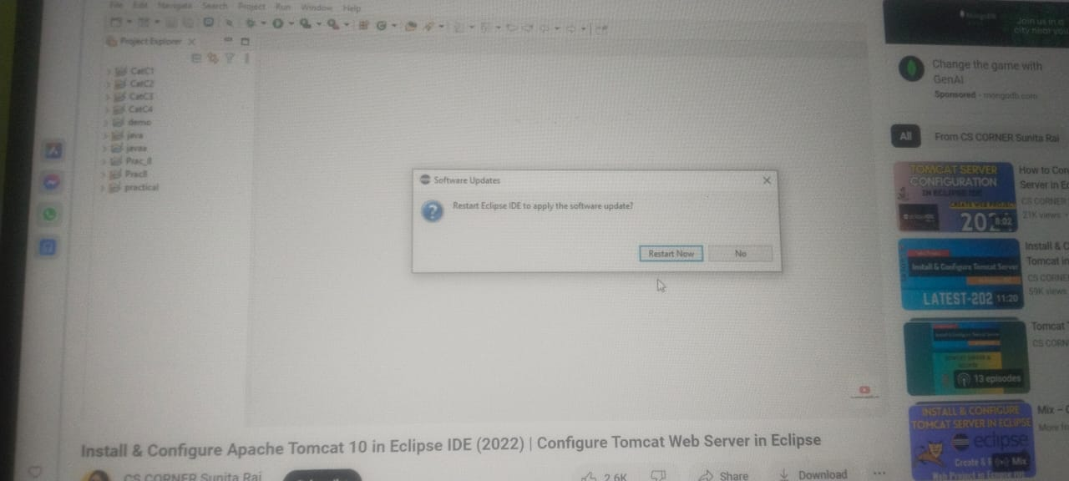
AFTER RESTART …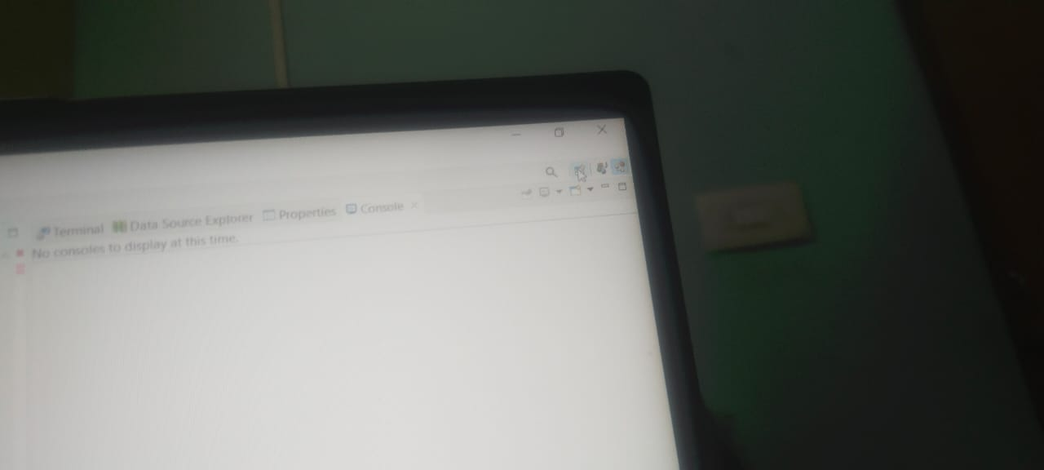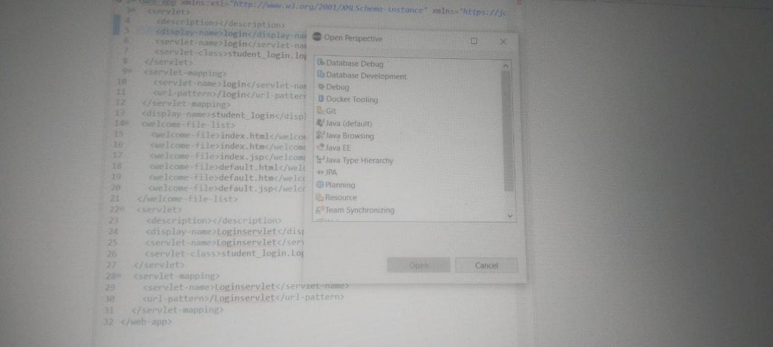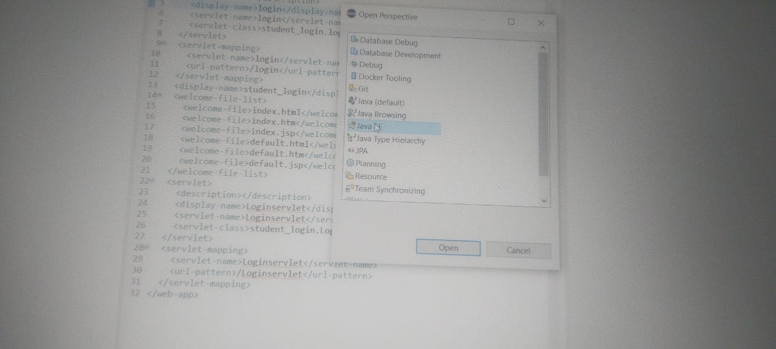
Select SERVER ON bule color LINK
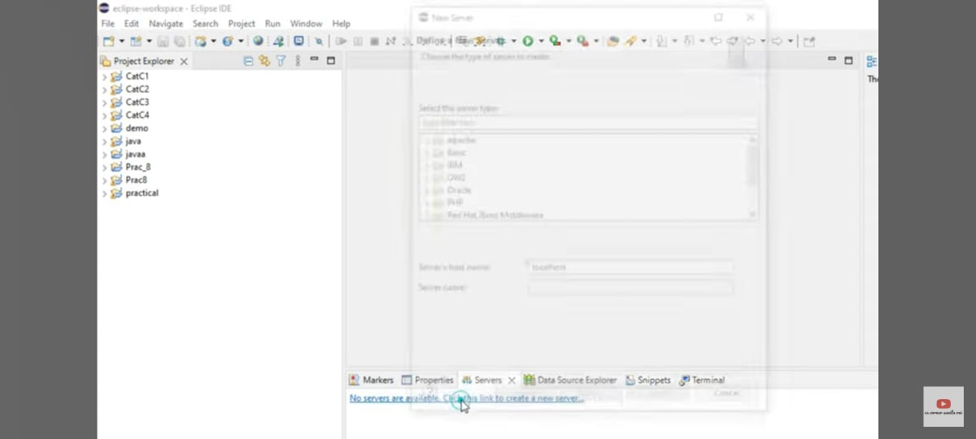
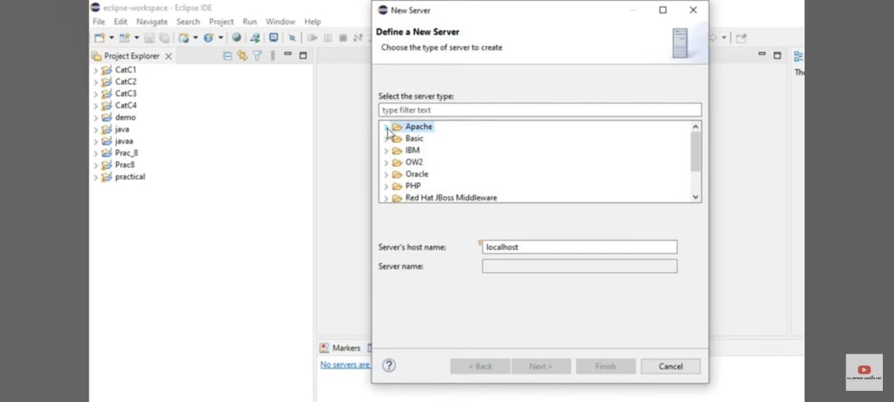
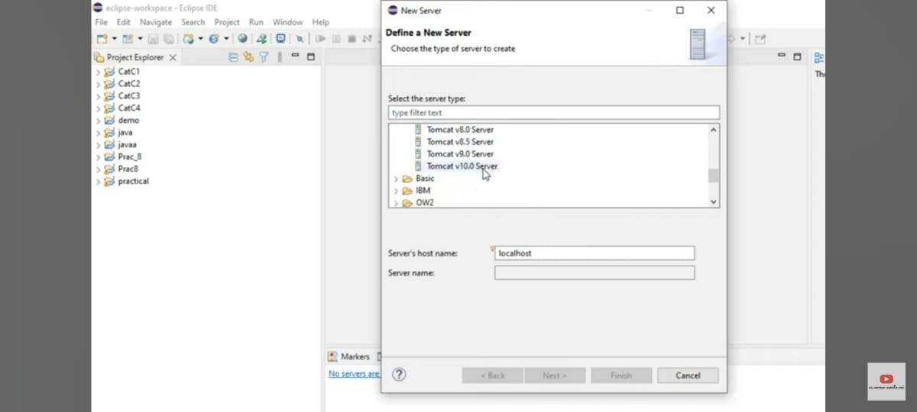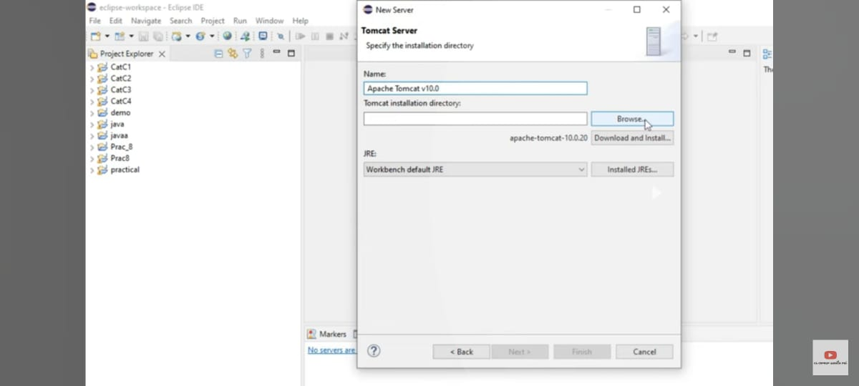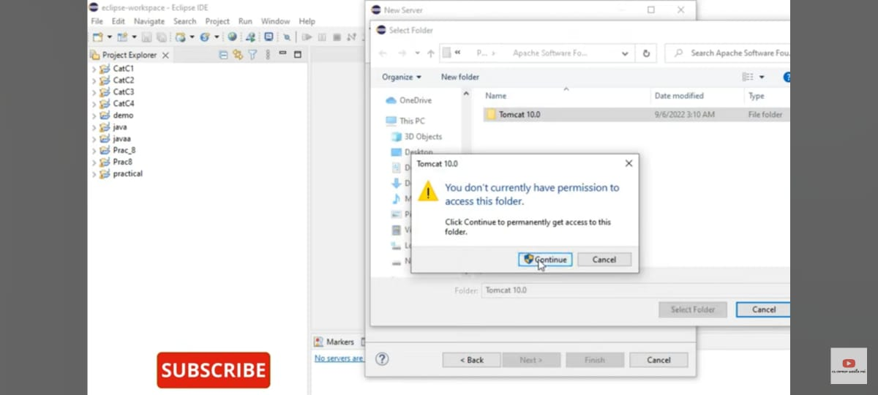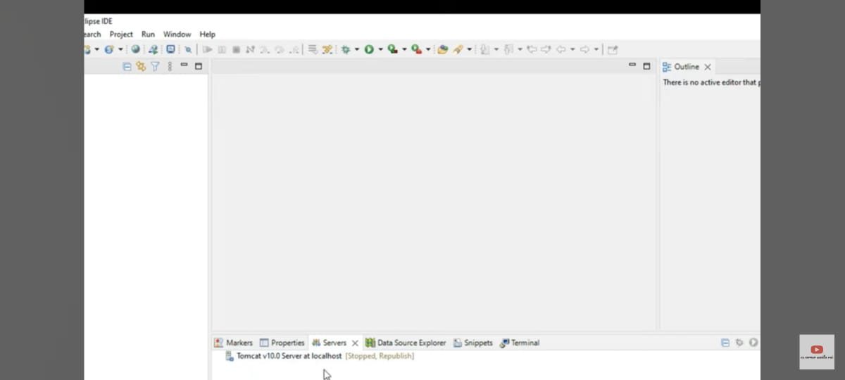
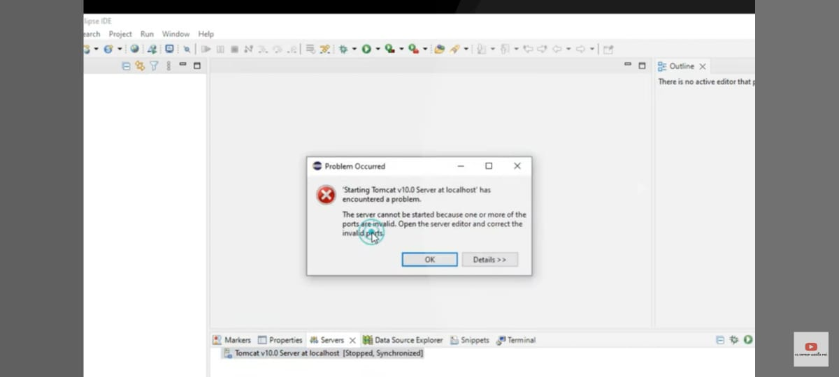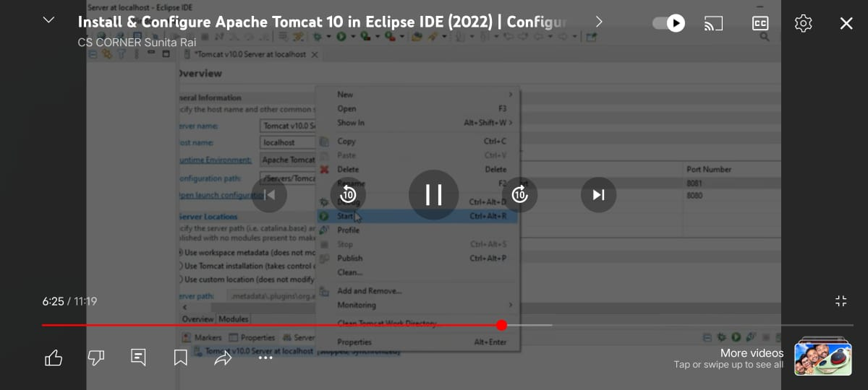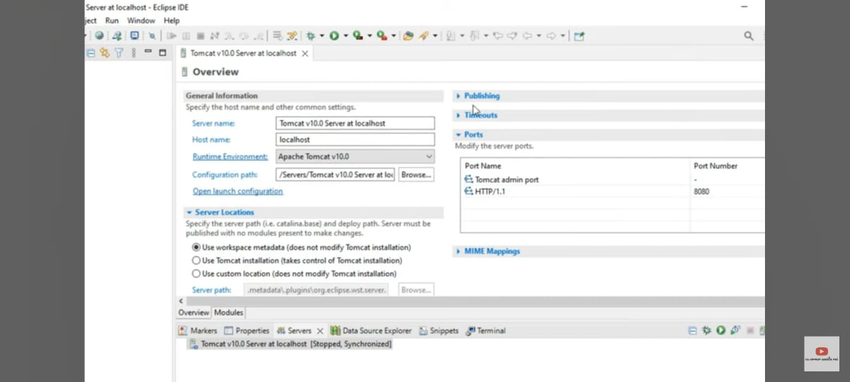
Change the port number of 8081 for http,admin port 8080
Server will runnn………..

Step 2: Check If JDK Is Installed. Open Command Prompt and enter the following commands
java -version

